**Program-1: Write a JavaScript to design a simple calculator to perform the following operations: sum, product, difference and quotient.**

<!DOCTYPE html>

<html>

<head>

<title>Experiment-1</title>

<style type="text/css"> table, td, th{ border: 2px solid; text-align: center; background-color: skyblue;

margin: auto;

}

input{

text-align: center;

}

</style>

<script type="text/javascript">

function calc(clicked_id)

{

var v1=parseFloat(document.getElementById("value1").value); var v2=parseFloat(document.getElementById("value2").value);

if(isNaN(v1) || isNaN(v2)) alert("Please enter a valid number"); else if(clicked_id=="add")

document.getElementById("answer").value=v1+v2; else if(clicked_id=="sub")

document.getElementById("answer").value=v1-v2; else if(clicked_id=="mul") document.getElementById("answer").value=v1*v2; else if(clicked_id=="div")

{

if(v2==0)

{

alert("Please Enter a Non Zero Denominator"); location.reload();

}

Else

document.getElementById("answer").value=v1/v2;

}

}

function cls()

{

value1.value="0"; value2.value="0";

answer.value="";

}

</script>

</head>

<body>

<table>

<tr>

<th colspan="4"> Simple Calculator </th>

</tr>

<tr>

<td>Enter Operand-1</td>

<td> <input type="text" id="value1" value="0"/></td>

<td>Enter Operand-2</td>

<td><input type="text" id="value2" value="0"/></td>

</tr>

<tr>

<td><input type="button" value="Addition" id="add" onclick="calc(this.id)"/> </td>

<td><input type="button" value="Substraction" id="Sub" onclick="calc(this.id)"/> </td>

<td><input type="button" value="Multiplication" id="mul" onclick="calc(this.id)"/> </td>

<td colspan="2"><input type="button" value="Division" id="div" onclick="calc(this.id)"/> </td>

</tr>

<tr>

<td> Result: </td>

<td> <input type="text" id="answer" value="" disabled/></td>

<td><input type="button" value="Clear All" id="cls" onclick="cls(this.id)"/> </td>

</tr>

</table>

</body>

</html>

**Output:**

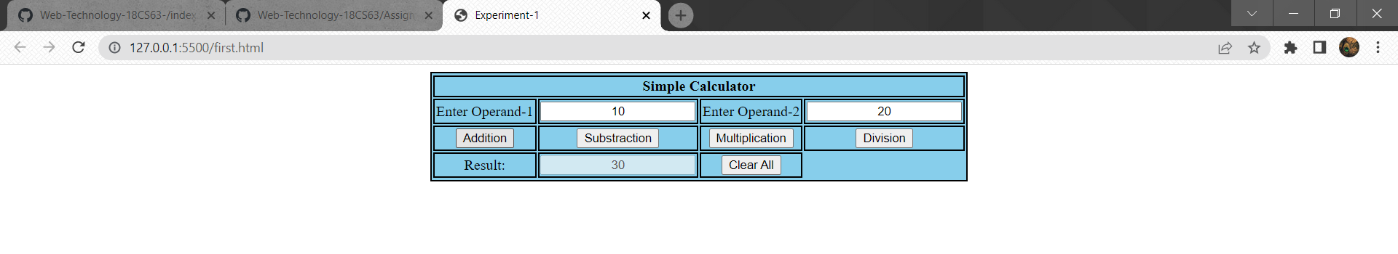

1. Test cases:

|  |  |  |  |  |
| --- | --- | --- | --- | --- |
| Test No. | Input  Parameters | Expected Output | Obtained Output | Remarks |
| 1.      2. | value1=50.56 value2=24.39      value1= 0  value2= 45 | Addition =74.95 | Addition =74.95 | PASS |
| Subtraction =26.17 | Subtraction =26.17 |
| Multiplication=1233.1584 | Multiplication=1233.1584 |
| Division=2.072980729807298 | Division=2.072980729807298 |
| Addition =45 | Addition =45 | PASS |
| Subtraction =-45 | Subtraction =-45 |
| Multiplication=0 | Multiplication=0 |
| Division=0 | Division=0 |
| 3. | value1= 45 value2= 0 | Addition =45 | Addition =45 | PASS |
| Subtraction =45 | Subtraction =45 |
| Multiplication=0 | Multiplication=0 |
| Division=Infinity | Division=Infinity |
| 4. | value1 = abc value2 = 23 | ENTER VALID NUMBER | ENTER VALID NUMBER | PASS |
| 5 | value1 = 50 value2 =xyz | ENTER VALID NUMBER | ENTER VALID NUMBER | PASS |

Case1: value1=50.56 value2=24.39 (Addition)



Multiplication:

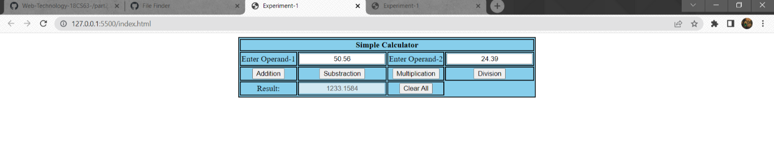

Division:

